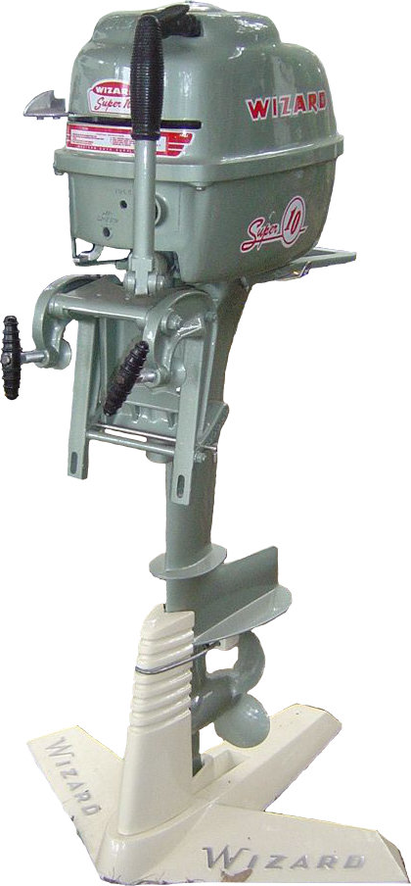
F O O T H I L L S

F O O T H I L L S

ANTIQUE POWER ASSOCIATION
ESTABLISHED 2003
October 2015
Dear Members,
The end of the year is fast approaching, but there are still quite a few events to participate in and enjoy. Hopefully you can get to many of them.

--- --- --- From the October Meeting --- --- ---

- Gracious Heavenly Father, You revealed yourself many years ago as The Lord Who Heals. We know you have not changed nor can you change. You are the same today as you were back then. We trust you as our Lord Who Heals to do what you do best.

  - Kelly Blanton
  - Glenn & Dot Hawn
  - Butch Minyard
  - Nancy Edgar
  - Gerry Stewart
  - Sheldon Smith
  - Rev. Bobby Langston
  - Allen Everdyke
  - Lorna Sheets
  - Charles Huffman
  - Steve Hefner
  - Penny Hodges
  - Justin Beach
  - Wade Hefner
  - Norris Turner
  - Don Johnson
  - Stewart (Ranny) Frye
  - Ned Story
  - Carl Porter
  - Jane Abernathy
  - Terry Martin
  - Jim Davis
  - Eugene Hartley
  - Charles McRee
  - Ann Cline
  - Hoyle Hoover
  - Carroll Hilliard
  - Missy Mullinax

- The Swap Meet was bigger this year than last. It is growing slowly, but it is growing.

- The Raffle Dinner was a success. All the tickets were sold and a good time was had by all at the meal and drawing.
  - Congratulations to all those who won the prizes.

- For a couple reasons the elections of officers and board members was not conducted at the October meeting. Instead it has been postponed for one month and will occur at the November meeting.

- Annual dues for the 2016 year can be paid at any time. Remember, the due date is Jan. 1. As always you can pay your $20 at the monthly meetings, at Sig’s Tire, Hollar Tractor, or you can mail it to the address given below.

- A couple events are coming up they you may want to participate in.
  - On Oct 17 a Fall Festival is being held on NC127 south across from Hawk’s Ridge Nursery. It starts at 9AM.
  - On Oct 25 at Christ Church, 2416 Zion Church Rd, Hickory, will be holding their Halloween Festival. They have asked us to provide tractors and wagons for hayrides. If you can assist, please do.

- Remember, too, the upcoming December meeting will feature the drawings for equipment featured on the 2016 Tee-shirt, program, and button.
  - In order to be eligible, you must have dues paid up, be present, and not selected during the previous 5 years.

--- --- --- UP-COMING EVENTS --- --- ---

Oct 9-11 Dallas Cotton Ginning Days
Oct 10 Simm’s BBQ Molasses Festival
Oct 16-18 Charlotte Stumptown Tractor Show
Oct 17 S. NC127 Fall Festival
Oct 22-24 Arden WNC Fall Harvest Days
Oct 25 Hickory Christ Church Fall Festival
Nov 5 Sig’s November meeting
Nov 6-8 Carthage Ken Eder’s Train & Tractor Show
Nov 7 Hickory Mt Grove Baptist Ch HarvestFest
Nov 26 Thanksgiving Day
Nov 28 Maiden Maiden Christmas parade
Nov 29 Newton Tree Lighting
Dec 1 Conover Tree lighting
Dec 3 Sig’s December monthly meeting
Dec 5 Claremont Christmas parade
Dec 5 Taylorsville Christmas parade

--- --- --- THE CLASSIFIEDS --- --- ---

Is there anything you would like to sell or are you looking for something special? List it here.
(Item listings will run for 3 months before expiring. Let us know when an item is sold or bought.)

FOR SALE

1939 John Deere B + cultivators & blade, Ruthie Conner, ruthieconner@gmail.com (15-08).

1941 John Deere A, Ruthie Conner, ruthieconner@gmail.com (15-08).

John Deere A & B for parts, Ruthie Conner, ruthieconner@gmail.com (15-08).

Massey-Harris Pony, Michael Rector, mikerector@aol.com 828-612-6309 (15-08).

2 Farmall Cubs, Michael Rector, mikerector@aol.com 828-612-6309 (15-08).

Woods belly mower, cultivators, plow, disc, sickle mowers, Michael Rector, mikerector@aol.com 828-612-6309 (15-08).

WANTED

John Deere B, Randy Rhodes, 828-394-2844, Jdeeretractor@hotmail.com (15-08).

☺ ☺ !!!!! HAPPY BIRTHDAY !!!!! ☺ ☺
October birthdays

1 – Doug Carrigan
1 – Brian McIntosh
5 – Tim Hollar
5 – Richard Hudson
6 – George Simmons
7 – David Setzer
8 – Bob Huffman
13 – Jeff Bowman
17 – Todd Painter
18 – Johnny Parsons
19 – Eugene Lefeber
19 – Tyler Lutz
28 – Keith Beck
28 – Richard Drum
28 – Glenn Hawn
28 – Jim Leatherman

November birthdays

3 – Jerry Matthews
4 – Howard Williams
5 – Cody Hastings
5 – Barry Propst
7 – Cory Keisler
10 – Jamie Allen
11 – Greg Williams
12 – Rusty Hastings
16 – Frank Frazier
16 – Tony Huffman
18 – Norris Turner
19 – Bruce Roseman
20 – Brandon Bowman
21 – Michael Harrill
21 – Zach House
22 – Bradley Fulbright
24 – Foster Edgar
26 – Kevin Black
27 – Henry Wagner
27 – Toby Aiken
28 – Donald Bowman
29 – Dennis Lutz

--- --- --- a thought for the month --- --- ---

The following is a short message given by a man named Richard Owen Roberts.

Did you ever set your heart to seek the Lord?
I didn’t ask did you seek the Lord at one time.
I asked, did you ever set your heart to seek the Lord?
If we don’t set our hearts to seek God, His kingdom, His righteousness, then what we’re going to do is to descend to the level of the pagan.
Our very nature is such that we are certain to seek something or someone. There isn’t anybody who doesn’t seek something, and if we follow our nature, we will seek the inconsequential. We’ve got to set our hearts to seek the Lord!
Dear friends, people have said to me, since being in this very church: “I don’t know that there is any hope.”
Don’t talk that way to me!
I worship and serve a God who, when His people seek Him, He lets them find Him.
The thing that concerns me is not will God let us find Him, but will we seek Him?
The failure is not on God’s part, obviously it’s on our part.
We can live in the hour of the greatest emergency of our entire lives and we can act as casually and indifferently as if we were living in the day of glorious spiritual victory and harvest.
If we will seek Him, He will let us find Him and our only hope is to seek the face of God.

God bless you.
See you in November.
Your Secretary,
David Setzer

5851 St. Peter’s Ch. Rd. Conover, NC 28613
President: Kevin Black 828-464-1950 Vice Pres: Wilson Sigmon 828-256-2176
Treasurer: Kermit Nash 828-459-9616 Secretary: David Setzer 828-850-4943
Show Chair: Ned Story 828-464-6399 Asst.Show Chair: Teddy Hefner 828-310-5525
Asst. Secretary: Kevin Sigmon 828-256-2176
www.foothillsantique.com

